17.1 Assignment

1. Write a program to read a text file and print the number of rows of data in the document.



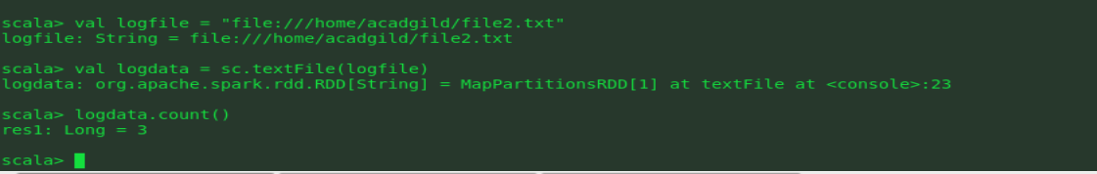

1. Write a program to read a text file and print the number of words in the document.





3. We have a document where the word separator is -, instead of space. Write a spark

code, to obtain the count of the total number of words present in the document.

